 VINOD SIR’S GROUP TUTION

MARKS: 21 MATHS-VIII TIME: 1 Hr. 30 Mins.

Q. 2: Do as directed: [10]1
1. If base of a parallelogram is 8 cm and height is 5 cm then find its area.
2. If Area of a parallelogram is 112 sq cm and base of it is 10 cm then find its height
3. Area of a rhombus is 96 sq cm. One of the diagonals is 12 cm find the length of its side.
4. Sides of a triangle are cm 45 cm, 39 cm and 42 cm, find its area.
5. Find the volume of a box if its length, breath and height are 20 cm, 10.5 cm and 8 cm respectively. r = 4.2 cm h = 14 cm

Q. 2: Do as directed: (Any 5) [15]

1. If perimeter of a rhombus is 100 cm and length of one diagonal is 48 cm, what is the area of the quadrilateral?
2.
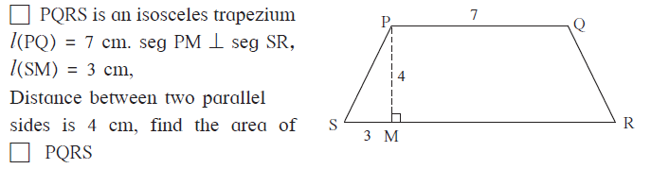
3.
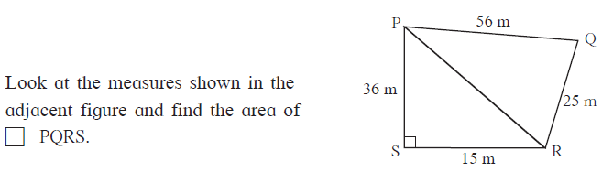
4. Find the measure of PQRST
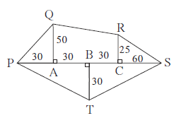
5. Areas of circle are given below find their diameters. 12474 sq.cm.
6. Find the area of base and radius of a cylinder if its curved surface area is 660 sqcm and height is 21 cm
7. How many bricks of length 25 cm, breadth 15 cm and height 10 cm are required to build a wall of length 6 m, height 2.5 m and breadth 0.5 m?

